
AI CHATBOT FOR CPS LAB USING n8n
What will you learn from this module:
In this experiment you will learn to build an AI-powered chatbot in n8n that fetches live CPS Lab sensor data through an API and answers the user’s questions using an OpenAI language model.
Requirements:
- Internet connection
- n8n Cloud account or local n8n installation
- Web browser
- OpenAI API key (or n8n Gateway credits)
- CPS Sensor API access
Prerequisites:
- Basic knowledge of workflow automation
- Basic understanding of APIs
- Basic understanding of JSON
- Basic understanding of AI/chatbots
Workflow Overview:
The chatbot is built from four nodes. The user’s message starts the workflow, the sensor API is called, and the AI model answers using the returned data.
Node name | n8n node type | Purpose
Chat Trigger | Chat Trigger (On chat message) | Opens the chat window and starts the workflow when the user sends a message.
Fetch CPS Sensor Data (API) | HTTP Request | Calls the CPS Lab sensor API and gets the live sensor values.
OpenAI Chat Model | OpenAI Chat Model | Provides the language model (gpt-3.5-turbo) to the chain. Needs an OpenAI credential (Gateway credits or your own API key).
Analyze Sensor Data | Basic LLM Chain | Sends the question + sensor data to the model and returns the answer to the chat.

Setup and Configuration:
Part A – Setup using n8n Cloud (online)
- Open a web browser and search for n8n cloud [1]. Click on the first link, n8n.cloud: Sign in [2], as shown in the picture below.
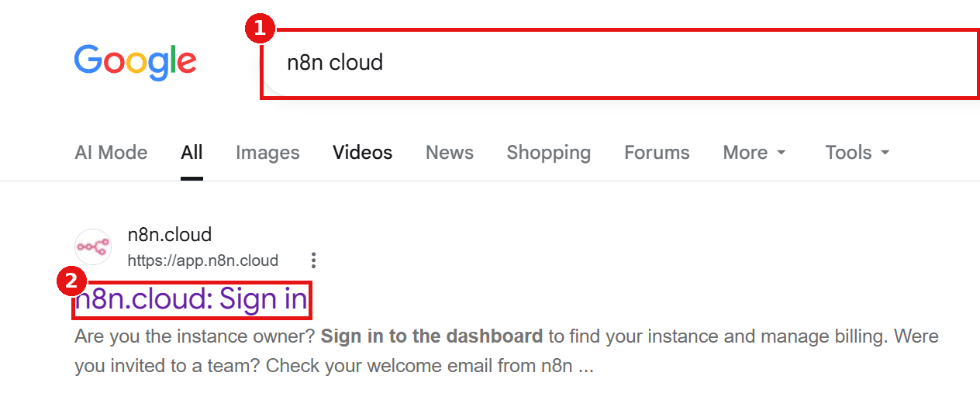
- On the sign-in page click on Start a free trial [1]. (If you already have an account, enter your n8n account name [2] and click Go to instance [3].)
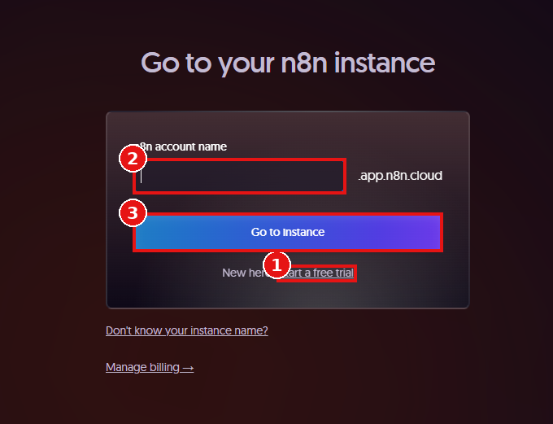
- Enter your company/e-mail address [1] and click on Submit [2].
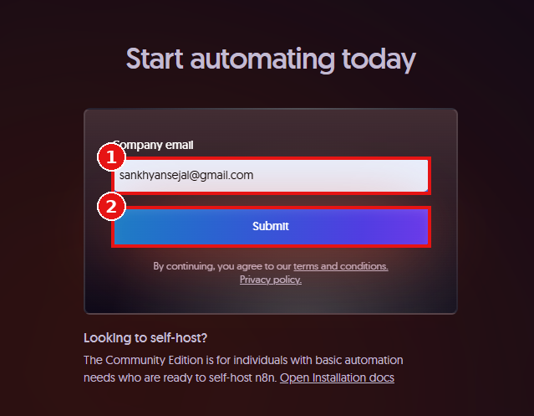
- Open your mailbox and click the verification link, or type the verification code in the boxes [1] and click Submit [2].
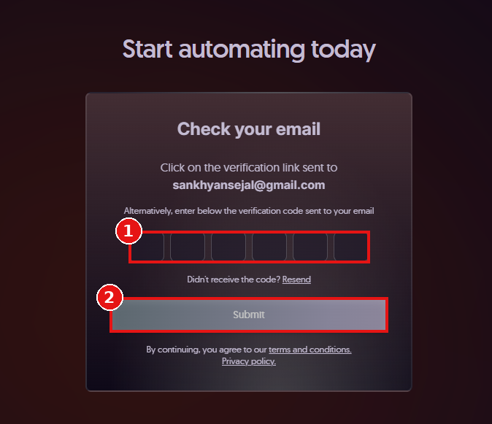
- On the Finish creating your account page enter your Full name [1], Password [2] and Account name [3].
- Tick the checkbox [4], then click on the start-trial button [5] to create your n8n Cloud account.
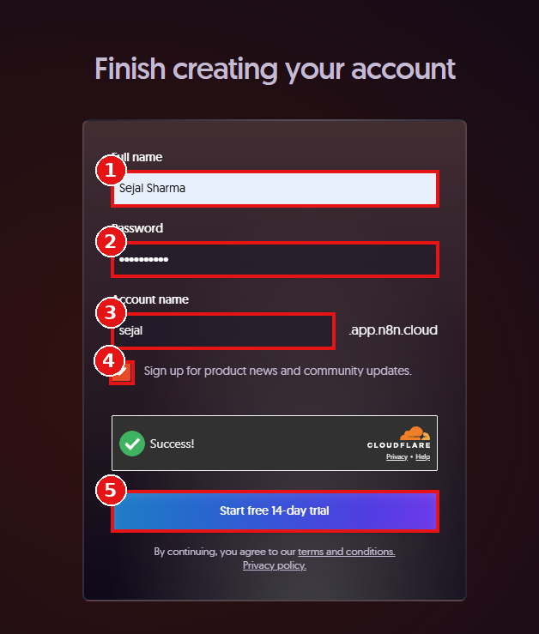
- After logging in, you will land on the n8n dashboard. Click on the + [1] button and select New workflow [2] to open an empty workflow canvas.
- Rename the workflow (top-left) to CPS Lab Assistant.
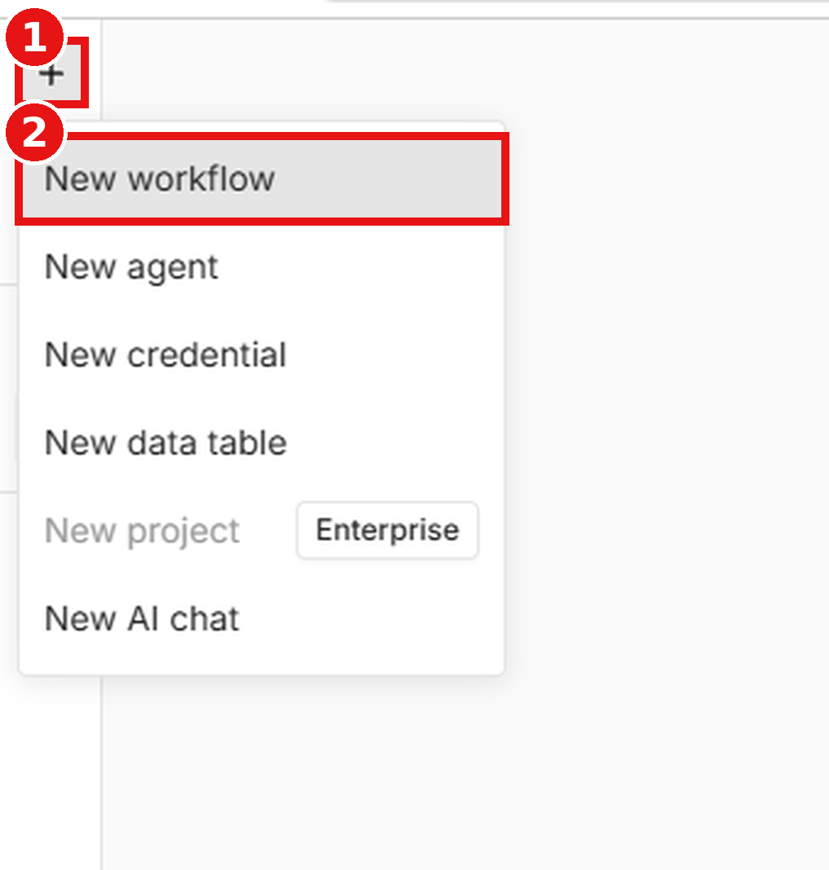
Part B – Setup using local n8n installation (on your computer)
Use this method if you want to run n8n on your own computer instead of n8n Cloud. After finishing Part B, continue with Part C.
Step 1: Install Node.js
- Search for nodejs.org download [1] on Google and click on the first link Download Node.js [2].
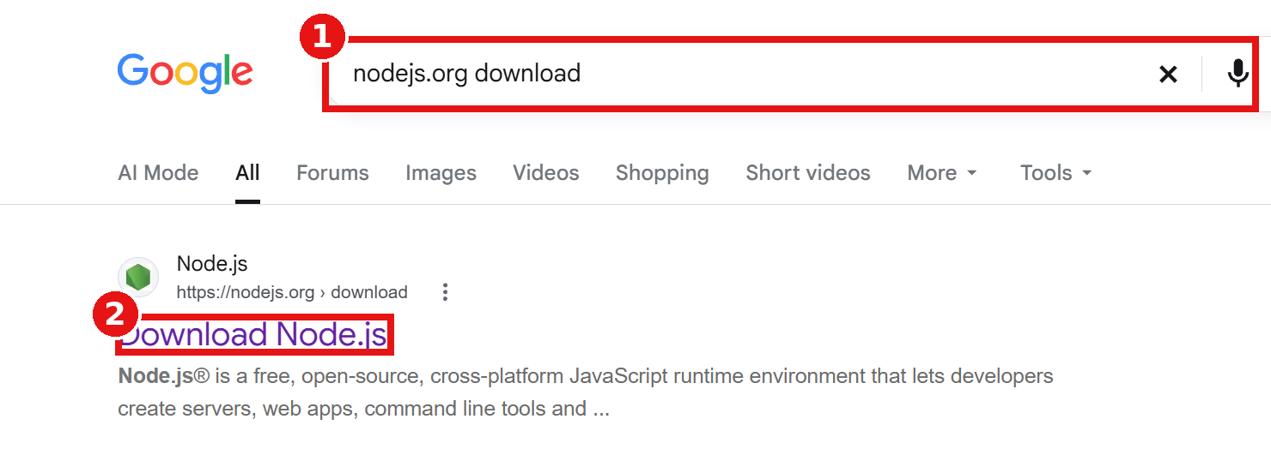
- On the download page select the LTS [1] version (n8n needs Node.js between 20.19 and 24.x) and click on Windows Installer (.msi) [2].
- Open the downloaded file, click Next on every page, accept the license, click Install and then Finish.
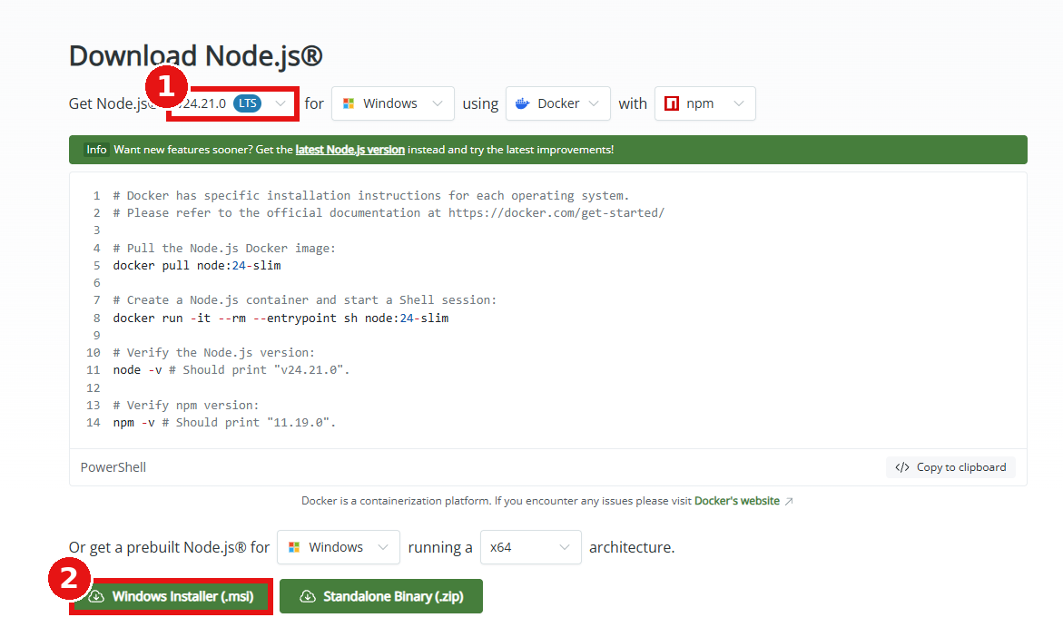
- Open Command Prompt (press Win + R, type cmd and press Enter) and check the installation by typing the commands below. The version numbers must be shown for node [1] and npm [2].

node -v
npm -v

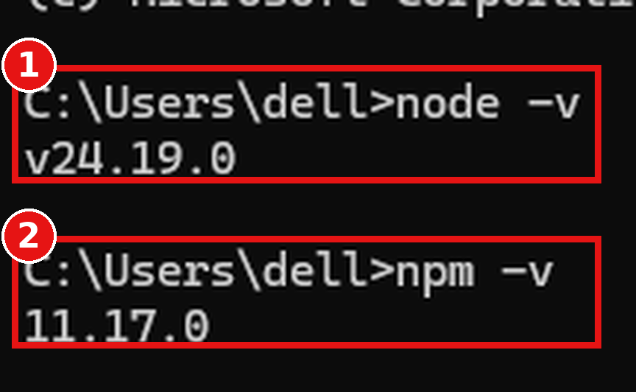
Step 2: Start n8n
- In the Command Prompt type npx n8n [1] and press Enter. If it asks Ok to proceed? [2] type y and press Enter. The first start downloads n8n, so wait for a few minutes.

npx n8n

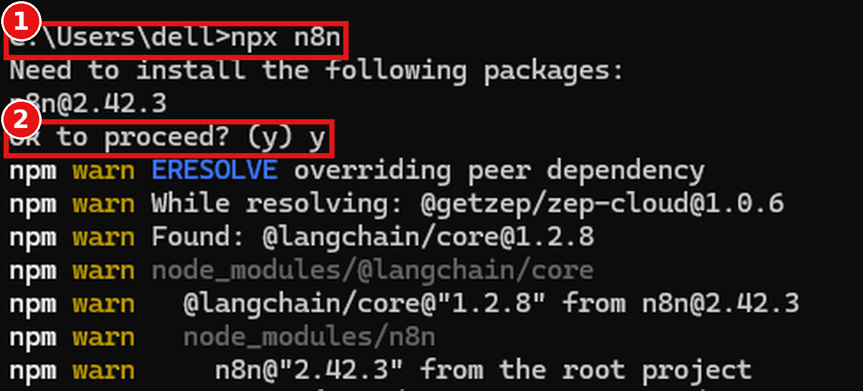
- When the message Editor is now accessible via http://localhost:5678 [1] appears, n8n is running. Press o [2] to open it in the browser (or open it manually in Step 3). Do not close this window while using n8n.
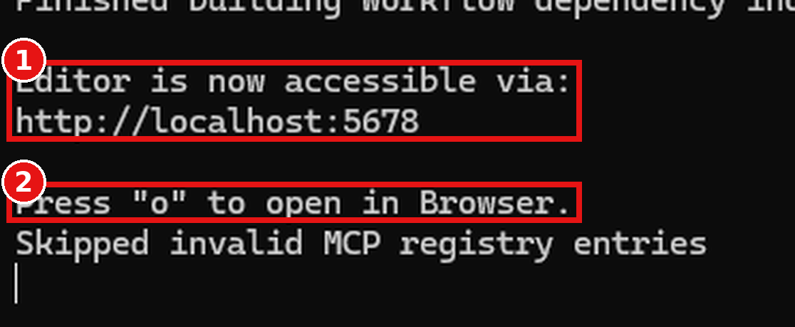
- Optional (permanent install): instead of npx you can install n8n once with the first command below and start it any time with the second command.

npm install n8n -g
n8n start

Step 3: Open the n8n editor
- Open a web browser and go to http://localhost:5678 [1].
- On the first start, the Set up owner account page appears. Enter your Email, First Name, Last Name and Password [2] and click on Next [3]. Skip the optional questions that follow.
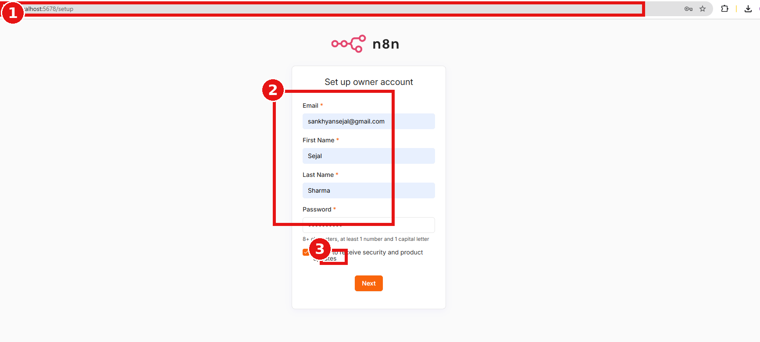
- The n8n dashboard opens. Click on the + [1] button, select New workflow [2] and rename the workflow to CPS Lab Assistant.
- Optional – using Docker: if Docker Desktop is installed, run the commands below instead of npx and then open http://localhost:5678.

docker volume create n8n_data
docker run -it --rm --name n8n -p 5678:5678 -v n8n_data:/home/node/.n8n docker.n8n.io/n8nio/n8n

Part C – Import the workflow using JSON code
- Copy the complete JSON code given below, paste it in Notepad and save the file as cps_lab_assistant.json [1] (set Save as type to All files).

{
"nodes": [
{
"parameters": {},
"id": "chat-trigger",
"name": "Chat Trigger",
"type": "@n8n/n8n-nodes-langchain.chatTrigger",
"typeVersion": 1.1,
"position": [ 100, 300 ]
},
{
"parameters": {
"url": "https://gtk47vexob.execute-api.us-east-1.amazonaws.com/polytechnicdata",
"sendQuery": true,
"queryParameters": {
"parameters": [
{ "name": "deviceid", "value": "7" },
{ "name": "startdate", "value": "01-10-2026" },
{ "name": "enddate", "value": "01-10-2026" },
{ "name": "key", "value": "Annam@2025" }
]
},
"options": {}
},
"id": "fetch-sensors",
"name": "Fetch CPS Sensor Data (API)",
"type": "n8n-nodes-base.httpRequest",
"typeVersion": 4.2,
"position": [ 300, 300 ]
},
{
"parameters": {
"model": {
"__rl": true,
"mode": "id",
"value": "gpt-3.5-turbo"
},
"options": {}
},
"id": "openai-model",
"name": "OpenAI Chat Model",
"type": "@n8n/n8n-nodes-langchain.lmChatOpenAi",
"typeVersion": 1.2,
"position": [ 500, 450 ]
},
{
"parameters": {
"promptType": "define",
"text": "=You are the CPS Lab Assistant. The user asked: {{ $('Chat Trigger').item.json.chatInput }}\n\nHere is the live sensor data from the lab: {{ JSON.stringify($json) }}\n\nPlease answer their question based on the sensor data."
},
"id": "analyze-sensor",
"name": "Analyze Sensor Data",
"type": "@n8n/n8n-nodes-langchain.chainLlm",
"typeVersion": 1.4,
"position": [ 500, 300 ]
}
],
"connections": {
"Chat Trigger": {
"main": [ [ { "node": "Fetch CPS Sensor Data (API)", "type": "main", "index": 0 } ] ]
},
"Fetch CPS Sensor Data (API)": {
"main": [ [ { "node": "Analyze Sensor Data", "type": "main", "index": 0 } ] ]
},
"OpenAI Chat Model": {
"ai_languageModel": [ [ { "node": "Analyze Sensor Data", "type": "ai_languageModel", "index": 0 } ] ]
}
}
}

- Open an empty workflow (created in Part A or Part B). Click on the ⋯ menu [1] next to the workflow name, then click on Import [2] → From file [3].
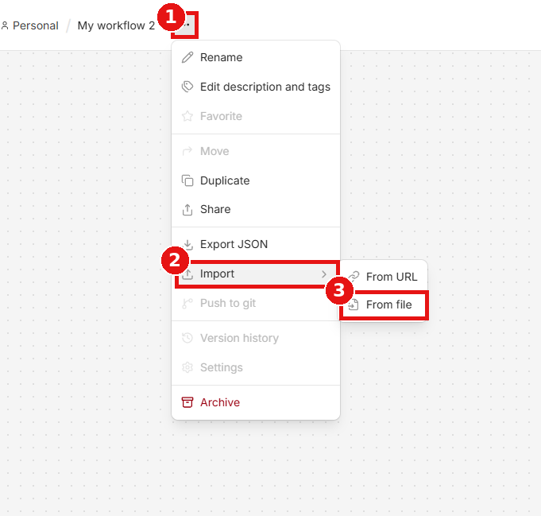
- In the file window select the saved JSON file [1] and click on Open.
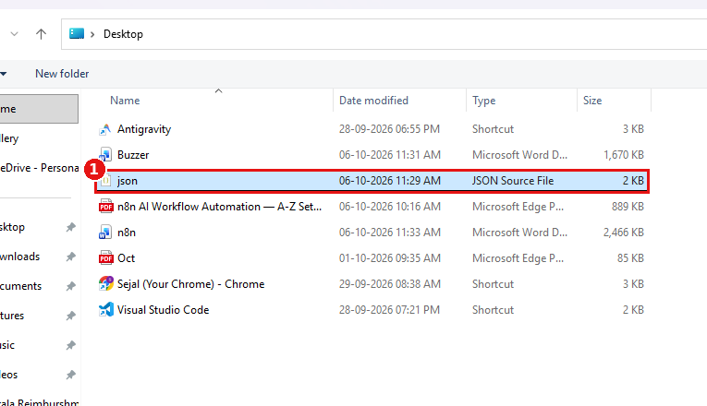
- All the nodes appear on the canvas, already connected to each other [1]. The OpenAI Chat Model [2] shows a red warning sign because its credential is not added yet. (Alternatively, copy the JSON code, click on an empty canvas and press Ctrl + V.)
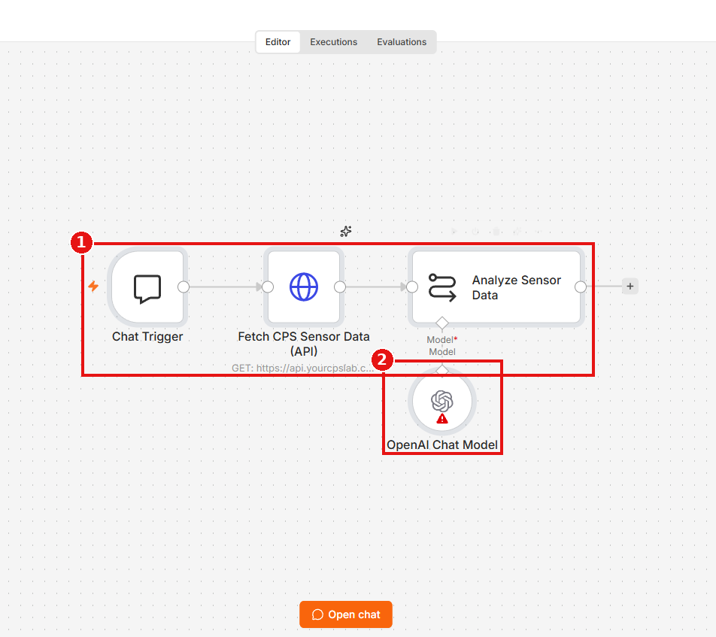
- Open the OpenAI Chat Model node (double-click it). In the Parameters tab, click the Credential [1] drop-down and select Gateway credits [2] (the free credits provided by n8n; the remaining balance, e.g. $2.00 left, is shown next to it). With Gateway credits you do not need to enter an OpenAI API key.
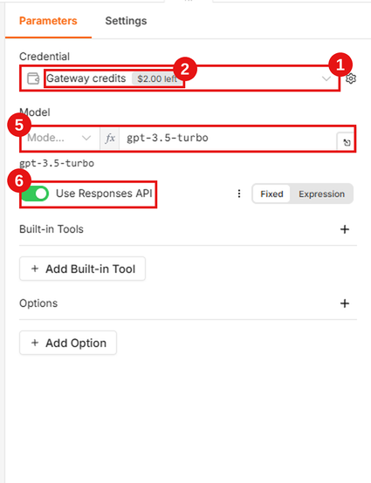
- Where to write your own OpenAI API key: if you want to use your own key, click the Credential [1] drop-down and choose Create new credential. Open platform.openai.com → API keys → Create new secret key, copy the key, paste it in the API Key [3] field of the credential window and click on Save [4]. The key is stored safely inside n8n; never write it in the prompt or in the HTTP Request node.
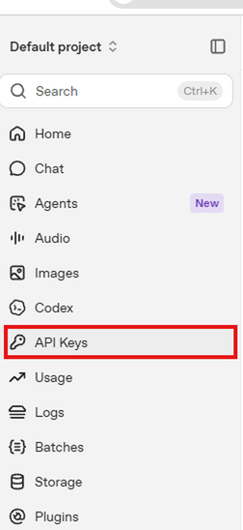 | 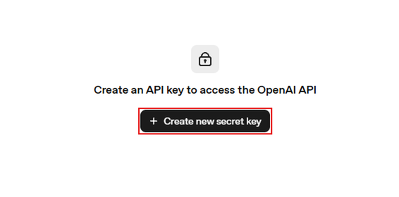

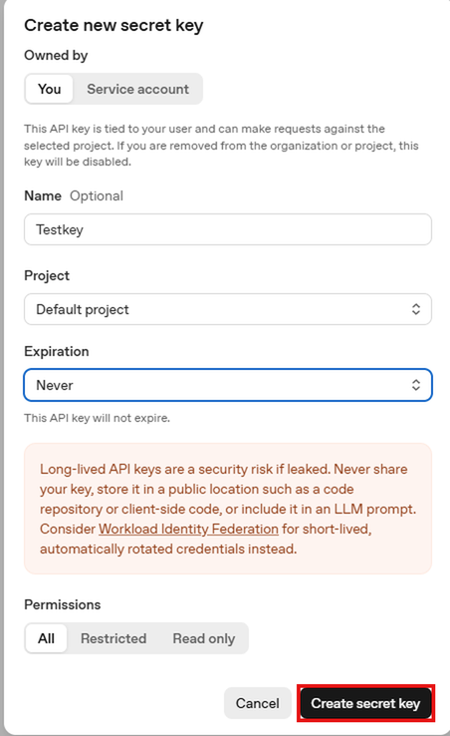 | 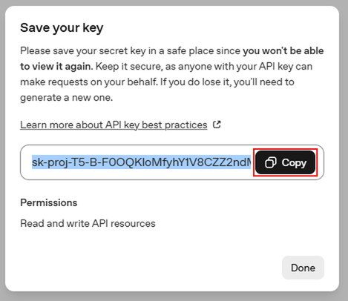

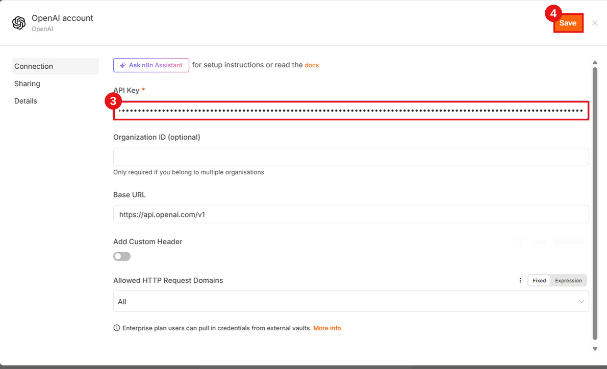
- Under Model [5] the value gpt-3.5-turbo is shown in the expression field. Keep the Use Responses API [6] switch ON (green) and leave Built-in Tools and Options empty.
- Open the Fetch CPS Sensor Data (API) node. Set Method to GET and in the URL [7] field enter the API address without the “?” part: https://gtk47vexob.execute-api.us-east-1.amazonaws.com/polytechnicdata
- Switch ON Send Query Parameters [8], click Add Parameter and add these four name / value pairs: deviceid = 7, startdate = 01-10-2026, enddate = 01-10-2026, key = Annam@2025 (your API key). Dates are in dd-mm-yyyy format. (Alternative: paste the complete link with “?deviceid=7&startdate=…” directly in the URL field.)
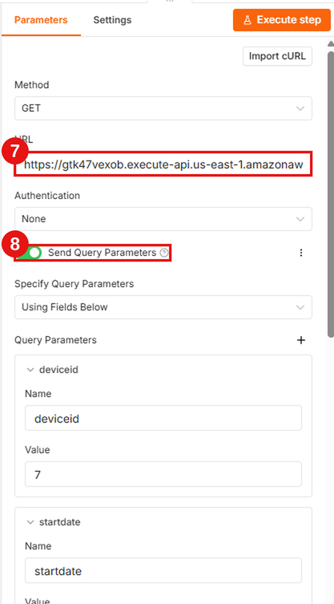
- Click on Save at the top-right corner to save the workflow.
- Note: In the prompt, JSON.stringify($json) passes the whole API response to the AI. If your API returns the readings inside a field named data, you may use {{ $json.data }} instead.
- Tip (today’s data): to always fetch the current date, set startdate and enddate to the expression {{ $now.toFormat('dd-MM-yyyy') }} instead of a fixed date.
Settings used in each node:
Node name | Setting | Value
Chat Trigger | Mode | Default (chat opens inside n8n)
Fetch CPS Sensor Data (API) | Method / URL | GET / https://gtk47vexob.execute-api.us-east-1.amazonaws.com/polytechnicdata + query parameters deviceid, startdate, enddate, key
Analyze Sensor Data | Source for Prompt | Define below – prompt: “You are the CPS Lab Assistant…” (already filled by the JSON)
OpenAI Chat Model | Credential / Model | Gateway credits (or your own OpenAI API key) / gpt-3.5-turbo, Use Responses API ON

Part D – Test the chatbot
- Click on the Open chat [1] button at the bottom of the canvas. The chat window opens.
- Type a question such as “What is the current temperature in the lab?” [2] and press Enter.
- The nodes turn green [3] one after another and the AI answer based on live sensor data is shown in the chat window [4].
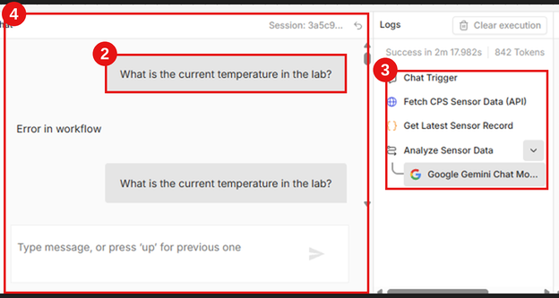 | 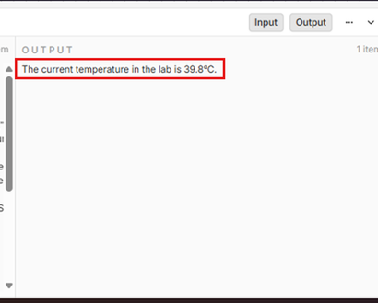

- To make the chatbot always available, switch the Active toggle [1] (top-right) ON. Open the Chat Trigger node and enable Make Chat Publicly Available [2] to get a shareable chat link.
- On a local installation the chat link works only on your own computer (localhost).
❖ OUTPUT :-
- The chatbot reads the live CPS Lab sensor data and replies to the user’s question in natural language, as shown below.
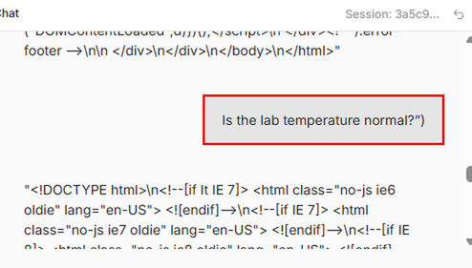 | 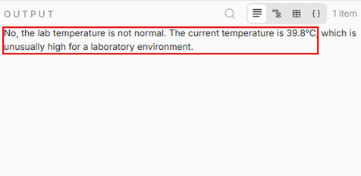

Troubleshooting:
Problem | Possible reason | Solution
HTTP Request node shows an error | Wrong URL or the API is not reachable | Check the URL, test it in a browser and make sure the CPS API is online.
OpenAI node shows “Invalid API key” or “Quota exceeded” | Wrong key or no credit in the OpenAI account | Create a new key and check billing/usage on platform.openai.com. If you use Gateway credits, check the balance shown in the Credential drop-down.
AI answer does not match the question | Chat input is missing in the prompt | Use the prompt of Step 3 that contains the Chat Trigger input.
Pasted JSON does not appear on the canvas | JSON copied incompletely | Copy the complete code from the first “{” to the last “}” and paste again.
‘npx’ or ‘node’ is not recognized | Node.js not installed or the terminal was opened before installing | Install Node.js LTS, then close and reopen Command Prompt.
n8n shows an error about the Node.js version | Node.js version is outside 20.19 – 24.x | Install a supported Node.js LTS version and run the command again.
localhost:5678 does not open | n8n is not running or the terminal was closed | Start n8n again and keep the Command Prompt window open.
Port 5678 is already in use | Another n8n or program uses the port | Close the other n8n window or restart the computer and start n8n again.

